  Lebanese University  Faculty of Sciences 5 | INFO449 E  Image, Video & Audio  Dr. Zein Al Abidin Ibrahim | Midterm 2014 - 2015  Date 18 April  Duration: 1 hour
Question I [10 pts]
A video source produces frames of 360 lines and 640 pixels per line with a rate 30 frames/s. The pixel aspect ratio is 16:9 and the color sub-sampling is 4:2:0. Each channel Y, U and V is quantized using 8 bits.
- What is the average bit per pixel?
- What is the bit-rate produced by the camera?
- What is the minimum size of the Hard disk needed to store a movie of one hour (in GBytes)?
- In order to reduce the size of the memory, the chrominance channels (U, V) are re-quantized using 4 bits per sample. What is the percentage of the memory reduction that can be obtained?
Question II [4 pts]
Consider the following array of Luminance Y and colour values (U,V) of an image, where each pixel is represented by the three channels (Y,U,V).
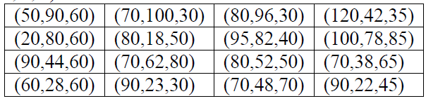
Give the Chroma sub-sampling results with 4:2:2, 4:1:1 schemes
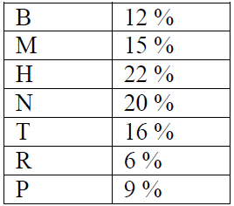
Question III [16 pts]
Suppose that we have a car selling market that should communicate messages with its main center on a daily basis. The messages sent are composed of the sequence of car make sold. The considered car makes are: BMW (B), Mercedes (M), Honda (H), Nissan (N), Toyota (T), Renault (R) and Peugeot (P). An example of communicated message is MBBMHMNTRRTB. Suppose you have a message composed of 100 symbols. The probability of each symbol is given in the right-side table. Answer the following:
- If no compression is used, how many bits per symbol is required and what is the total length of the message?
- What is the entropy of the message?
- Suppose that we want to compress the messages sent using the Huffman coding algorithm. Draw the Huffman tree.
- What is the new average bits per symbol and what is the efficiency of your codes?
- What is the compression ratio?
In order to improve the efficiency of the compression, instead of sending the category of each car sold, the main center asks you to transmit an information indicating only the manufacturing country of the sold cars: Germany={B,M}, Japanese (J)={H, N, T} and French (F)={R,P}.
- What is the entropy of the message?
- Design new Huffman codes and compute the efficiency of the codes.
- An improvement of the efficiency is still desired. Can you design another Huffman code to represent the manufacturing country information more efficiently? Justify

